**St John’s College**

**Trust Board**

**2019**

C:\Users\ghope\AppData\Local\Microsoft\Windows\INetCache\Content.Word\College1.png**ANNUAL**

**REPORT**

# INTRODUCTION

On behalf of Trustees, it is a pleasure to present the 160th Annual Report[1] of the St John’s College Trust Board, the Trust having been established on the 18 August 1859.

The St John’s College Trust Board (“SJCTB” or “Trust”) is represented by two principle trusts, the College Funds and the Scholarship Funds. The purposes of these separate trusts, while related, are different and as defined in the St John’s College Trusts Act 1972 (“Act”).

Section 3(1) of the Act details the purpose of the College Funds as:

*(a) For or towards the maintenance and support of the College:*

*(b) For the education in the College of candidates for ordination:*

*(c) For the costs of the education of students of all races in such manner and in such places as the General Synod shall from time to time direct so long as such education includes instruction in the principles of the Christian faith.*

The purposes of the Scholarship Funds are defined in section 7(1) and (2) of the St John’s College Trusts Act 1972 (“Act”) as follows:

*… towards the maintenance and support of candidates for ordination or persons who have been ordained (and their dependents respectively) while taking a course of study for a degree or diploma at any University or University College or any other course of study within New Zealand or elsewhere.*

As discussed below, Trustees are bound by law to adhere to the purposes of these trusts.

# GOVERNANCE

The persons appointed by the General Synod Standing Committee to hold office as trustee of the St John’s College Trust Board during the 2018 and 2019 period were as follows:

Mr Kevin Wearne, Chair

The Most Rev. Philip Richardson

The Most Rev. Don Tamihere (Appointed 2018)

Rev. Sue Fordyce (Appointed 2018)

Mr Joseph Halapua

The Ven. Don Rangi

Ms Moka Ritchie

The Ven. Maui Tangohau

Ms Mele Tuilotolava

In accordance with the provisions of Canon II, Title E, Trustees appointed Mr Kevin Wearne, on an annual basis, to act as the Chair of the Trust for this same period.

During 2018 and 2019 Trustees have concentrated their focus on compliance with the St John’s College Trusts Act 1972, which is in effect the Trust Deed governing the activities of the Trust, and Canon II, Title E. The importance of adherence to the terms of these foundational documents was highlighted in the report received from the Commission established to review the roles of the Trust and Te Kotahitanga, as determined by these documents.

That said, and despite the finding of the Commission, the Trust’s desire to continue to adhere to the terms of the Trust appears to continue to result in frustrations being expressed when funding applications are declined. Trustees acknowledge that at times they are unable to fund all the wishes of applicants, but are unapologetic when this is due to the need to adhere to the terms of the trusts.

That said, Trustees are aware the needs of the Anglican Church of Aotearoa, New Zealand and Polynesia continue to change and at times may not always align to the terms of the Trust set in 1972. However, Trustees are confident that the terms of the Trust are broad enough to meet the education needs of the Church as long as the education being funded includes education in the principles of the Christian faith and is aligned to the education strategies of Amorangi, Diocese and the Church as a whole.

In this regard, Trustees look forward to the findings of the research project being undertaken by Te Kotahitanga to analyse the education needs of the Church from 2020 to 2040. It is anticipated that the outcome of this project, Te Pae Tawhiti, will be available in 2021 for further consideration.

# DISTRIBUTIONs processES

The Trust has also continued to focus on its processes for the receipt, review and determination of funding applications, in liaison with Te Kotahitanga.

The 2019 year was the second year where the Trust received funding applications via the new online process. In fact, using this process, the Trust and Te Kotahitanga received and considered over 450 applications during the 2019 year.

While the Trust believes further enhancements to the application processes are required and will be implemented, the process so far implemented has achieved the objective of improved transparency while feedback has been that the majority of applicants have found the application process easier.

Greater focus on the distribution process, and adherence to the purposes of the Trust, has however identified a number of matters that require further consideration and clarification to ensure the Trust can continue to meet the education needs of the Church.

The Trust will continue to work on these matters, in conjunction with Te Kotahitanga and other bodies within the Church, and will advise any changes to its processes via amendments to its Funding Manual which can be found on the Trust’s website[2].

The Trust has also continued to undertake reviews of funding recipients to gain a greater understanding of their activities and ensure funding is being utilised in accordance with the provisions of the Trust and consistent with the funding applications approved. Trustees intend to continue to undertake these reviews, as part of fulfilling governance duties and as the feedback has been that these reviews have also been beneficial to the reviewee.

# SUMMARY FINANCIAL PERFORMANCE

In the 2019 financial year the Trust generated an operating surplus of $19.9 million (2018: $16.2 million) reflecting continued strong returns primarily from its property and equity investments. In addition the Trust generated capital gains of $45.9 million, and while much of this gain is unrealised, it is indicative of very positive performance of the Trust in strong investment markets.

This performance is summarised in the following table:

|  |  |  |  |
| --- | --- | --- | --- |
|  | **2019**  **$’million** |  | **2018**  **$’million** |
| Operating revenue | 26.0 |  | 21.8 |
| Operating expenditure | 6.1 |  | 5.6 |
| **Operating surplus** | **19.9** |  | **16.3** |
| Capital gains | 45.9 |  | 14.9 |
| **Total surplus** | **65.8** |  | **31.1** |

The recorded capital gain has increased the investment capital of the Trust to $482 million, an 11% increase for the year.

In addition to the investment capital of the Trust is the value of St John’s College in Meadowbank, Auckland. While a recent valuation indicated the value of the College to be in the region on $53 million, this asset is recorded by the Trust at its depreciated historical book value of $44 million.

Therefore the total recorded capital of the consolidated Trust is $526 million and is represented as follows:

|  |  |  |
| --- | --- | --- |
|  | **2019**  **$’million** |  |
| Current assets | 5.0 |  |
| Current liabilities | (1.7) |  |
| Property investments | 251.6 |  |
| Fixed interest investments | 39.6 |  |
| Equity investments | 160.8 |  |
| Loans receivable | 11.2 |  |
| Property held for sale | 15.8 |  |
| Investment Capital | 482.3 |  |
| Value of St John’s College | 44.0 |  |
| **Total capital** | **526.3** |  |

As at 31 December 2019 the Trust had entered into an unconditional contract to sell a commercial property located on Queen Street Auckland, giving rise to the reclassification of this asset to a ‘Property held for sale’. This sale settled on 31 January 2020.

The balance of loans receivable includes the present value of the advance made to the Te Aute Trust Board in 2014. The present value of the loan is $10.7m is secured by mortgages over the whenua owned by the Te Aute Trust Board, and is repayable in 2024.

The Trust’s capital of $526 million is in turn represented by the capital of the individual trusts for which the St John’s College Trust is responsible, as follows:

|  |  |  |
| --- | --- | --- |
|  | **2019**  **$’million** |  |
| College funds | 315.6 |  |
| Scholarship funds | 192.7 |  |
| Marsh scholarship fund | 18.0 |  |
| **Total surplus** | **526.3** |  |

It should be noted that this report, and the above financial analysis, has been prepared on the basis of the Trust’s management reports as the audit and finalisation of the Trust’s financial statements for the year ended 31 December 2019 has yet to be concluded.

# DISTRIBUTIONS

During the 2019 year the Trust made distributions totalling $15.9 million (2018:$15.6 million) representing an aggressive 3.7% of the investment capital of the Trust. The Trust has also approved distributions for the 2020 year totalling $17.6 million, although some of this funding will likely be spread over multiple years.

The Trust often receives feedback that distributions are either not high enough or do not increase over time. However, not only is the Trust distribution at an industry high level, but the 2019 level of distribution marks a 45% increase in distributions over the last decade, a period in which inflation was 17%.

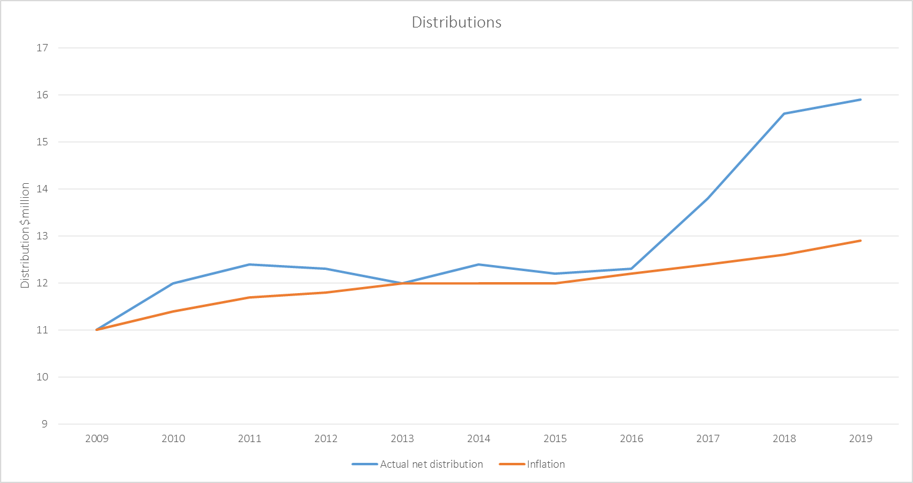

In fact, a detailed analysis of distributions indicates that in fact the distributions received by funding recipients, notably Amorangi and Diocese, have doubled over this period.

Trustees are therefore comfortable that both the level of distribution and the current growth in distributions is appropriate.

Of this level of distribution, $15.3 million or 96% was represented by funding recipients falling under section 3(1) of the Act. As such, under the provisions of section 8 of the St John’s College Trust’s Act 1972, on receipt of advice from Te Kotahitanga, Trustees used their discretion to transfer surplus income of approximately $4.1 million from the Scholarship Fund to the College Fund, in order to make these distributions.

However, despite transferring this surplus income of the College Fund, Trustees note that distributions made in accordance of the Scholarships Fund totalled only $0.6 million from its capital of $192.7 million, just 0.3%.

While Trustees are mindful of balancing the needs of recipients of the College Funds and Scholarship Funds, Trustees wish to work with the Church to better utilise the Scholarship Funds to meet the needs of the Church, especially when it is believed many eligible scholarships are in fact being incorrectly funded from the College Funds including via St John’s College.

# INVESTMENT STRATEGY

The Trust’s financial performance is a direct reflection of the success of the Trust’s investment strategy. Given its importance, Trustees formally review this strategy, and the resulting financial forecasts, on an annual basis in addition to reviewing the performance of the Trust’s investments throughout the year.

As part of its normal investment strategy deliberations, the Trust has considered the place of impact investments as part of its normal review of the investment portfolio’s ESG[3] characteristics and diversification objectives.

The Trust has determined that impact investing shall play a part in its overall investment strategy and has agreed that an allocation of its portfolio be directed to impact investments in addition to its wider Responsible Investment objectives.

Importantly, the Trust has defined an impact investment as an investment that has an intentional social objective that is intended to produce a return that is commensurate with the risk of the investment.  Trustees, believe that the second leg of this test is important to ensure that the Trust remains true to its charitable purpose and acts as a prudent investor.

To date the Trust has investigated a number of impact investment opportunities, and has made a cornerstone investment in one impact fund.  However, a number of proposals have been rejected as the Trust’s assessment was that either the impact investment thesis was not able to be demonstrated or the risk/return balance was not appropriate, normally due to a high concentration to a small number of high risk investments, including being geographically limited or there being no exit strategy evidenced.

At the present time the Trust is investigating two further impact investment opportunities.

# ACKNOWLEDGEMENTs

The Church is blessed by the size and of the St John’s College Trust Board as an endowment, which provides significant funding to the Church in terms of the funding of its education requirements.

However, given the scale of the Trust’s operation, it is an entity that often becomes involved in complex and sensitive transactions, which require careful consideration and a significant time commitment by Trustees.

While the Trust is well supported, Trustees undertake this work on behalf of our three Tikanga Church on a voluntary basis and seek the prayerful support of General Synod/Te Hinota Whanui in fulfilling their fiduciary duties.

Similarly Trustees wish to record their gratitude to members of the Board’s Secretariat and staff of Trust Investments Management Limited who continue to advise Trustees in a professional manner and efficiently execute the resolutions of the Board. The partnership between the Trust and Trust Management is very strong and is critical to the ongoing success of the Trust.

Kevin Wearne  
Chair

February 2020

1. The Trust was formed by way of a deed signed by The Right Reverend George Augustus Selwyn dated 18 August 1859.
2. [www.sjctb.co.nz](http://www.sjctb.co.nz)
3. Environment, Social and Governance